NAME : LASYA MADHURYA REDDY JANGA
ROLL NO : 2503A52661
BATCH : 23
ASSIGNMENT : 2.1
Task 1: Statistical Summary for Survey Data

- Scenario:
You are a data analyst intern working with survey responses stored as numerical lists.

- Task:
Use Google Gemini in Colab to generate a Python function that reads a list of numbers and calculates the mean, minimum, and maximum values.
PROMPT:
Write a simple Python function that takes a list of numbers and calculates the mean, minimum, and maximum values. Include sample input and print the output clearly. Make the code beginner-friendly and ready to run in Google Colab.
CODE:
def calculate_statistics(numbers):
"""Return the mean, minimum, and maximum of a list of numbers."""
mean = sum(numbers) / len(numbers)
minimum = min(numbers)
maximum = max(numbers)

return mean, minimum, maximum

# Sample input
numbers = [10, 20, 30, 40, 50]

# Calculate the statistics
mean, minimum, maximum = calculate_statistics(numbers)

# Print the output clearly
print("Numbers:", numbers)
print("Mean:", mean)
print("Minimum:", minimum)
print("Maximum:", maximum)

OUTPUT:
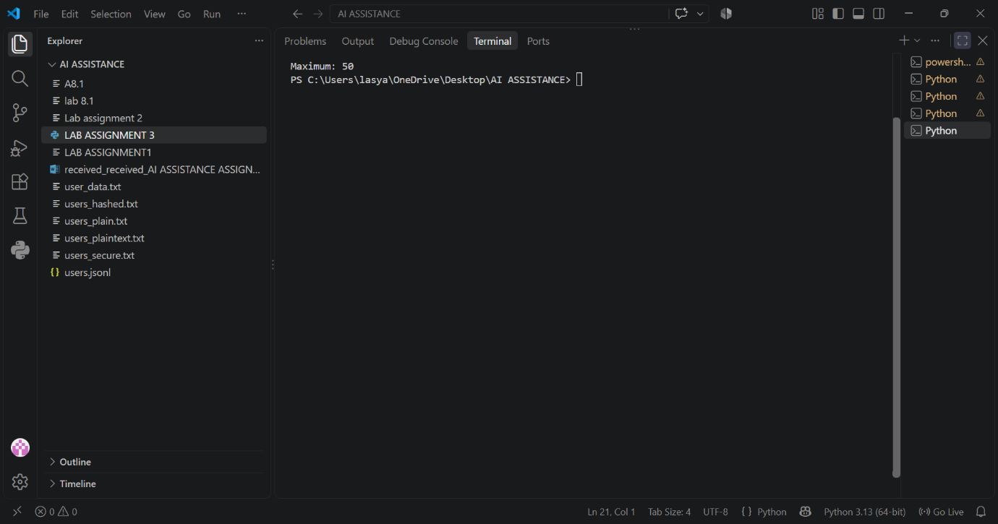
Task 2: Armstrong Number – AI Comparison

- Scenario:
You are evaluating AI tools for numeric validation logic.

- Task:
Generate an Armstrong number checker using Gemini and GitHub Copilot.
Compare their outputs, logic style, and clarity.
PROMPT:
Write a simple beginner-friendly Python program to check whether a given number is an Armstrong number or not.
Requirements:
- Take the number as input from the user.
- Check whether it is an Armstrong number.
- Display a clear result.
- Use simple Python logic and explain the code briefly.
- Make the code ready to run in Google Colab.
CODE:
"""Check whether a number is an Armstrong number.

An Armstrong number is equal to the sum of its digits raised to the
power of the number of digits. For example, 153 = 1**3 + 5**3 + 3**3.
This program can be run directly in Google Colab.
"""

number = int(input("Enter a number: "))

if number < 0:
is_armstrong = False
else:
digits = str(number)
number_of_digits = len(digits)
sum_of_powers = sum(int(digit) ** number_of_digits for digit in digits)
is_armstrong = sum_of_powers == number

if is_armstrong:
print(f"{number} is an Armstrong number.")
else:
print(f"{number} is not an Armstrong number.")

OUTPUT:
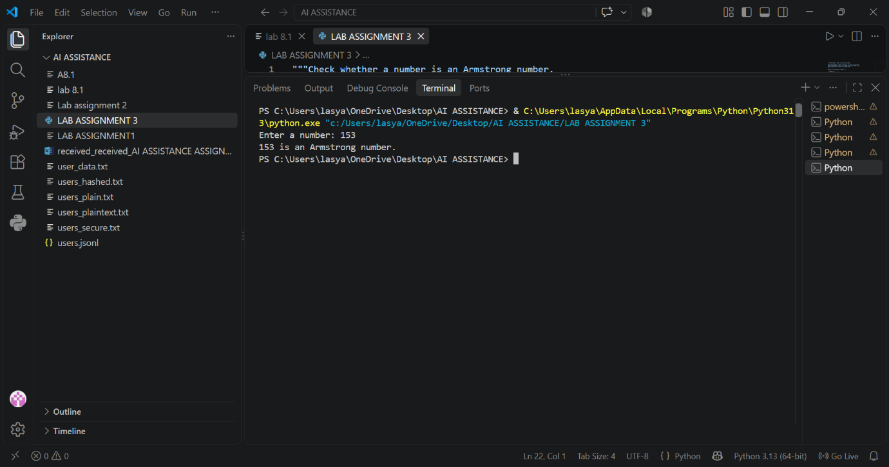
Task 3: Leap Year Validation Using Cursor AI

- Scenario:
You are validating a calendar module for a backend system.

- Task:
Use Cursor AI to generate a Python program that checks whether a given year is a leap year.
Use at least two different prompts and observe changes in code.
PROMPT:
Write a simple beginner-friendly Python program to check whether a given year is a leap year or not. Take the year as user input and display a clear result. Use basic if-else conditions and include a sample input and output.
CODE:
year = int(input("Enter a year: "))

if year % 400 == 0:
print(year, "is a leap year.")
elif year % 100 == 0:
print(year, "is not a leap year.")
elif year % 4 == 0:
print(year, "is a leap year.")
else:
print(year, "is not a leap year.")

# Sample input:
# Enter a year: 2024
# Sample output:
# 2024 is a leap year.

OUTPUT:
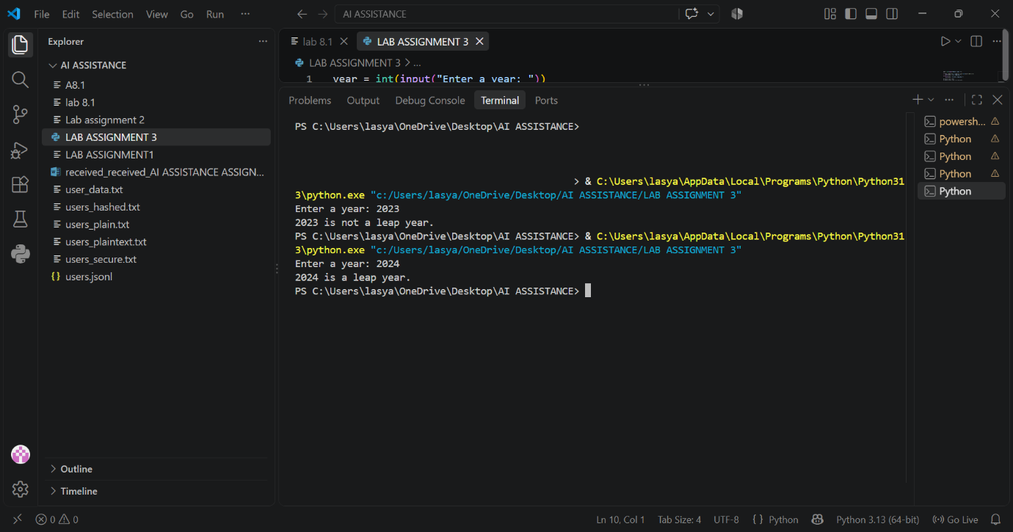
Task 4: Student Logic + AI Refactoring (Odd/Even Sum)

- Scenario:
Company policy requires developers to write logic before using AI.

- Task:
Write a Python program that calculates the sum of odd and even numbers in a tuple, then refactor it using any AI tool.
PROMPT:
Refactor the following Python program that calculates the sum of odd and even numbers in a tuple.
Requirements:
- Keep the same functionality and output.
- Make the code simpler, cleaner, and more readable.
- Use beginner-friendly Python.
- Explain the improvements made.
- Provide sample input and output.
Original code:
numbers = (1, 2, 3, 4, 5, 6)
odd_sum = 0
even_sum = 0

for num in numbers:
if num % 2 == 0:
even_sum += num
else:
odd_sum += num

print("Sum of odd numbers:", odd_sum)
print("Sum of even numbers:", even_sum)
CODE:
"""Calculate the sums of odd and even numbers in a tuple.

Improvements:
- Uses clear variable names.
- Uses built-in ``sum`` with simple conditions, avoiding manual counters.
- Keeps the logic short and easy to read.

Sample input:
(1, 2, 3, 4, 5, 6)

Sample output:
Sum of odd numbers: 9
Sum of even numbers: 12
"""

numbers = (1, 2, 3, 4, 5, 6)

odd_sum = sum(number for number in numbers if number % 2 != 0)
even_sum = sum(number for number in numbers if number % 2 == 0)

print("Sum of odd numbers:", odd_sum)
print("Sum of even numbers:", even_sum)

OUTPUT:
